Curriculum Vitae

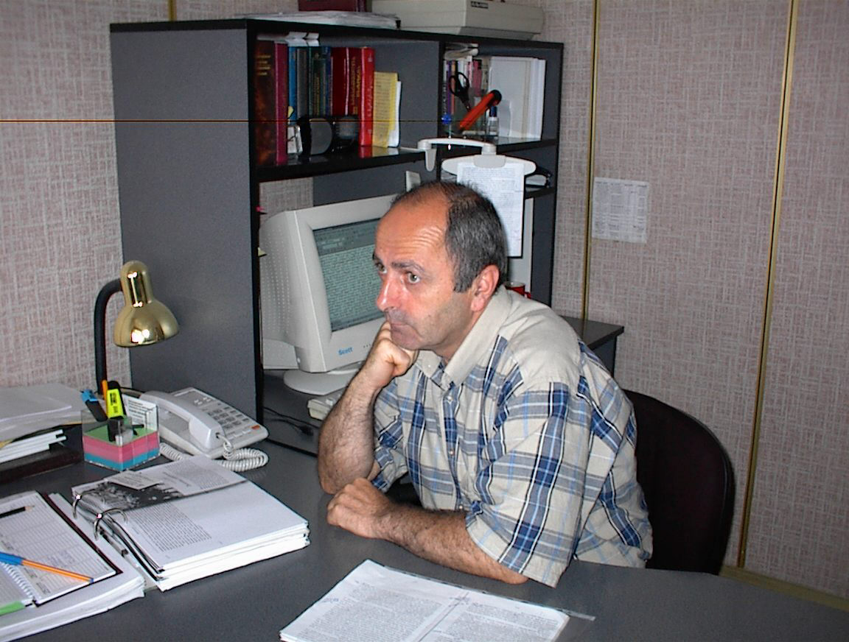

Jokhadze Avtandil

Permanent Address: 22, Iloris St. Tbilisi. 0101, Georgia

Work Address: 1, Tsereteli Avenue. 0154. Tbilisi, Georgia

Home Phone: (995-32) 2689463

Work Phone: (995-32) 2355154

Fax: (995-32) 2355754
Mob. (995-77) 425683
E-mail: avto-jok@cipdd.org

Date of Birth: 22 April, 1952

Education:
2008 - Ilia Chavchavadze State University - doctoral student. Dissertation - "Preconditions of Liberalism in Georgian History "
1982-1986 - Post graduate study - Institute of Philosophy, Academy of Sciences of Georgia
1971-1976 - Tbilisi State University, Philosophy and Psychology Department

Trainings:
Human Resource Management (CTC - Centre for Training and Consultancy - Local agency for NGO development) Tbilisi, Georgia, April 2001;
Project Cycle Management (CTC - Centre for Trainings and Consultancy - Local agency for NGO development) Tbilisi, Georgia, May 2001;
NGO Activities Assessment (EFQM - European Foundation for Quality Management), Tbilisi, Georgia, 2002;
Policy Analysis (CIPDD - Caucasus Institute for Peace, Democracy and Development), Tbilisi, Georgia, April 2008;
Fund Raising (Cordaid and Venture for Fund Raising), Tbilisi, Georgia, Jun 2008.
Training for Trainers - (CTC - Centre for Training and Consultancy) Tbilisi, Georgia 2012.

Work Experience:
Executive director - The Caucasus Institute for Peace, Democracy and Development - 1996 - until the present
Member of State Constitutional Commission of Georgia - 2009
Member of Civil Society and Media Development Program Commission (Open Society Georgia Foundation OSGF) - 2008
Publisher - Publishing House "Lomisi" - 1993-1996
Lector - State Pedagogical Institute - 1988-1989
Editor and Translator - Board of Translator, Georgian Writers' Union - 1980-1993
Library Manager - Board of Translators, Georgian Writers' Union - 1978-1980

Publications:
Articles and scientific publications of historical, religious and political issues
(Some of them are translated into English: "10 Questions on Georgia's Political Development" - Collected articles "Political Forum" - Tbilisi 2007; "The Role of the Media" - Collection - Newspapers outside the Capital" - Tbilisi 2007…)

Translations:
Works by Russian religious philosophers
Pieced of Russian classical literature

Languages:
Language Reading Specking Writing
Georgian 5 5 5
Russian 5 4 4
English 4 3 3

Computer skills:
Microsoft office programs

Internet

